# 

# 

# 

# 

# 

# 

# 

# 

## 

## 

## 

## 

## 

## **Table of Contents**

Table of Contents 2

**Introduction 5**

Background and Context 5

Project Vision and Mission 5

Objectives 6

Key Features 6

Target Audience 7

Regional Impact Potential 7

**System Design and Components 8**

1. Physical Components 8

a. Raspberry Pi Server 8

b. Storage System 8

c. Local Wi-Fi Router 8

d. Power Supply 9

e. Enclosure 9

2. Software Components 10

a. Operating System 10

b. FLB Software Stack 10

c. Content Management System 10

3. Networking and Connectivity 11

a. Local Access 11

b. LAN Connectivity (Optional) 11

c. Optional Internet Connectivity 11

4. User Interfaces 12

a. Learner Interface 12

b. Teacher/Admin Dashboard 12

5. Design Principles and Benefits 12

**Educational Content 13**

1. Curriculum-Aligned Courses 13

2. Digital Library 13

3. Audiobooks and Multimedia 14

4. AI and Offline Tools ( Part of sustainable plan ) 14

5. Content Localization ( Part of sustainable plan ) 14

6. Content Management 15

**Deployment and Implementation 16**

1. Pilot Phase 16

2. Rollout Strategy 17

3. Facilitator , Volunteer and Teacher Training 17

4. Community Engagement 18

5. Monitoring and Maintenance 18

6. Scalability and Replicability 18

**Training and Capacity Building 19**

1. Facilitator and Volunteer Training Program 19

2. Teacher Capacity Development 20

3. Student Digital Literacy Programs 20

4. Community Workshops 21

5. Capacity Building Outcomes 21

**Monitoring and Evaluation (M&E) 22**

1. Objectives of M&E 22

2. Data Collection Methods 22

3. Key Performance Indicators (KPIs) 23

4. Reporting and Feedback 23

5. Evaluation Outcomes 24

**Achievements to Date 24**

1. Pilot Site and Rollout Deployment 24

2. Educational Impact 25

3. Volunteer and Teacher Impact 25

4. Community Engagement 25

5. Success Stories 26

6. Recognition and Partnerships 26

**Roadmap and Future Plans 27**

1. 12 - Month Plan (Short-Term) 27

2. 24 - Month Plan (Mid-Term) 28

3. 36-Month Plan (Long-Term) 28

4. Key Strategic Principles 29

**Partnerships and Collaborations 30**

1. Local NGO Partners 30

2. Educational Institutions 30

3. International Organizations and Donors 30

4. Technology and Content Partners 31

5. Community Stakeholders 31

6. Partnership Benefits 31

**Appendices and Technical Documentation 32**

1. Hardware Setup Guide 32

2. Software Installation Guide 32

3. Admin and Teacher User Guide 33

4. Learner User Guide 33

5. Maintenance and Sustainability 33

6. Reference Materials 34

7. Replicability Checklist 34

**Impact Stories and Testimonials 35**

1. Student Stories 35

2. Teacher Testimonials 36

Teacher 1 – Daw Hla ( Other Name) , Primary School 36

Teacher 2 – U Ko ( Other Name ) , Middle School 36

3. Volunteer Experiences 36

Volunteer 1 – Thar(Other Name ), Community Volunteer 36

Volunteer 2 – Nyein, Youth Volunteer 36

4. Community Feedback 36

5. Qualitative Impact Highlights 37

**Conclusion and Call to Action 37**

1. Key Takeaways 37

2. Opportunities for Donor Support 38

3. Why Support FLB 38

4. Call to Action 38

# 

# 

# 

# 

# **Introduction**

## **Background and Context**

The **Fortitude Learning Box (FLB)** is a resilient, offline-first digital learning solution designed to address the **digital divide in rural and conflict-affected communities**. In regions like Karenni State and IDP camps in Karenni, many students and teachers have **limited or no access to the internet**, which severely constrains educational opportunities.

FLB provides **preloaded courses, digital libraries, and multilingual audiobooks** through a compact, low-power server (Raspberry Pi + SSD + local Wi-Fi router), enabling **self-contained learning hubs** in schools, community centers, and temporary learning spaces.

By offering a **ready-to-use, locally maintainable learning ecosystem**, FLB empowers learners to access quality education **without relying on internet connectivity**, bridging gaps in literacy, digital skills, and STEM education.

## **Project Vision and Mission**

**Vision:**To create **resilient, inclusive, and technology-enabled learning environments** for underserved communities, enabling learners to achieve their full potential regardless of infrastructure limitations.

**Mission:**

* Provide **offline access to high-quality educational content** tailored to local languages and curricula.
* Empower **teachers, volunteers, and community facilitators** to deliver digital literacy and academic instruction.
* Build **sustainable, replicable models** for learning centers that can operate independently of internet connectivity.

## 

## 

## **Objectives**

1. **Educational Access:** Deliver structured curriculum content for Grades 1–12 in local languages ( Burmese, English , later on Karenni).
2. **Digital Literacy:** Equip learners and teachers with essential skills for computer use, safe internet practices, and problem-solving.
3. **Community Empowerment:** Train local volunteers to manage and maintain learning boxes, fostering local ownership.
4. **Resilient Infrastructure:** Create low-maintenance, solar-compatible, portable setups for areas with unreliable power.

## **Key Features**

* **Offline Digital Learning:** Fully functional without internet, with optional offline syncing when volunteer/facilitators are going to the FLB Hub.
* **Multilingual Content:** Localized course material, digital library, and audiobooks.
* **Scalable Deployment:** Can serve from 30 to 100 learners per site, can enhance with clustered deployments for larger centers.
* **Admin Dashboard:** Teacher and volunteer management, learner tracking, and progress reports.
* **Low Power Consumption:** Raspberry Pi and SSD-based system optimized for energy efficiency.

## **Target Audience**

* Students (Grades 1–12) in rural schools and IDP camps.
* Teachers, facilitators, and community volunteers.
* NGOs, local education partners, and community centers.
* Policy-makers and donors supporting digital equity initiatives.

## **Regional Impact Potential**

The implementation of FLB in pilot sites has shown potential for **significant educational and social impact**, including:

* Increased **digital literacy** among students and teachers.
* Continuous learning opportunities despite **internet outages or political restrictions**.
* Greater **community engagement** through local volunteers managing the learning hubs.
* Creation of a **replicable model** for other underserved regions in Myanmar and neighboring countries.

# 

# 

# **System Design and Components**

The Fortitude Learning Box (FLB) is designed as a **portable, offline, and scalable digital learning solution**. It combines **robust hardware, optimized software, and localized content** to deliver high-quality education in low-resource environments.

## **1. Physical Components**

### **a. Raspberry Pi Server**

* **Model:** Raspberry Pi 5, 8GB RAM
* **Role:** Core processing unit running the FLB software stack.
* **Features:** Energy-efficient, compact, supports Docker containers for content delivery.
* **Benefits:** Low power consumption (~10–15W), easy to maintain, durable for field deployment.

### **b. Storage System**

* **Device:** 256GB SSD (expandable to 1TB)
* **Role:** Houses all educational content, courses, digital library, and user data.
* **Benefits:** High-speed read/write for smooth access, low maintenance compared to HDD, rugged for transport.

### **c. Local Wi-Fi Router**

* **Capacity:** 30–200 simultaneous connections depending **on deployment size of Raspberry PI server.**
* **Role:** Provides local network connectivity to learners’ devices without internet.
* **Benefits:** Stable connection for large groups, allows multiple devices to access content simultaneously.

### **d. Power Supply**

* **Options:** 100W USB-C power adapter, solar kit, and battery inside.
* **Role:** Ensures continuous operation in areas with unreliable grid electricity.
* **Benefits:** Enables deployment in off-grid or mobile learning environments.

### **e. Enclosure**

* **Type:** Portable, ventilated, ruggedized case.
* **Role:** Protects hardware from dust, moisture, and accidental damage.
* **Benefits:** Ensures longevity and safe handling in remote or mobile settings.

**f. Tablets (x300)**

* **Type:** Android-based educational tablets.
* **Role:** Provide students and community members with access to curated offline and online educational content.
* **Installed Software:**
  + Media & Information Literacy (MIL) – digital safety and awareness.
  + Digital Literacy Modules – basic computer and mobile skills.
  + 360ED Applications (Grade 1 & 2 English) – interactive language learning.
  + Learning App – general subject-based practice and exercises.
  + First Aid (သူနာပြု) – basic healthcare and emergency response training.
  + MRE Application – mine risk education and safety awareness.
  + Agricultural Applications (e.g., Greenway) – farming guidance and sustainable practices.
  + Painting App – creative expression and art skills.
  + Scratch Junior (STEM Support) – beginner coding and problem-solving.
* **Benefits:** Delivers diverse, localized, and interactive learning opportunities for children and adults, supporting literacy, safety, STEM, health, and livelihood development.

## **2. Software Components**

### **a. Operating System**

* **OS:** Raspberry Pi OS (64-bit) - ARM Architectures
* **Role:** Stable base for running FLB applications and network services.
* **Features:** Security updates, lightweight, supports Docker.

### **b. FLB Software Stack**

* **Core Applications:**
  + Content delivery (HTML5 web interface)
  + Admin dashboard for teachers and volunteers
  + Usage tracking and reporting tools
* **Dependencies:** Docker, Docker Compose, Python 3.10+, database (MariaDB/)
* **Benefits:** Modular design allows easy updates, scalability, and integration with other platforms like Moodle or Kolibri.

### **c. Content Management System**

* **Role:** Enables uploading, updating, and organizing courses, library materials, and audiobooks.
* **Features:** Supports multilingual content, metadata tagging, categorization by grade/subject.

## **3. Networking and Connectivity**

### **a. Local Access**

* FLB operates as a **Wi-Fi hotspot**; learners connect their devices without requiring internet.
* Supports multiple simultaneous users with minimal latency.

### **b. LAN Connectivity (Optional)**

* Wired Ethernet connection for computer labs or high-density deployments.
* Provides stable bandwidth for resource-heavy content like videos.

### **c. Optional Internet Connectivity**

* When available, FLB can synchronize content, collect analytics, and download updates and users can access the internet when our setup is connected to Starlink internet.
* Supports bandwidth management to prevent overuse in limited internet areas.

## 

## 

## 

## 

## 

## **4. User Interfaces**

### **a. Learner Interface**

* Accessible via any Wi-Fi-enabled device (phones, tablets, laptops).
* Simple, multilingual web-based interface for accessing courses, library, and audiobooks.

### **b. Teacher/Admin Dashboard**

* Web-based interface for managing users, tracking progress, assigning courses, and generating reports.
* Role-based access ensures secure administration.

## **5. Design Principles and Benefits**

* **Portability:** Compact design for classrooms, libraries, or mobile kits.
* **Resilience:** Hardware and software optimized for low-resource, high-need environments.
* **Scalability:** Suitable for small classrooms (30-50+ learners) or large centers (300+ learners - based on deployment model).
* **Sustainability:** Low energy consumption, durable components, and minimal maintenance requirements.

# **Educational Content**

The Fortitude Learning Box (FLB) delivers a **comprehensive, multilingual, and offline-ready educational content ecosystem**. Content is curated to align with **local curricula**, **digital literacy goals**, and **21st-century learning skills**.

## **1. Curriculum-Aligned Courses**

* **Grades Covered:** 1–12, including primary, middle, and high school.
* **Subjects:** Mathematics, Science, Language Arts, Social Studies, ICT, and Computer Literacy.
* **Content Format:** HTML5 lessons, interactive quizzes, video tutorials, and PDF resources.
* **Impact:** Ensures continuity of learning even in areas without teachers or schools.

## 

## **2. Digital Library**

* **Resources Included:** Offline Wikipedia, open-source textbooks, PDFs, research articles, and reference materials.
* **Multilingual Support:** Karenni, Burmese, English.
* **Access Method:** Web interface with search, categories, and grade-based filtering.
* **Benefits:** Provides learners with broad knowledge resources, encouraging self-paced learning.

## 

## 

## 

## **3. Audiobooks and Multimedia**

* **Content Type:** Storybooks, educational lessons, podcasts, and narrated textbooks.
* **Languages:** Local languages and English.
* **Purpose:** Supports literacy, listening skills, and comprehension for learners with varying reading abilities.
* **Advantages:** Encourages engagement for younger learners and communities with low literacy levels.

## **4. AI and Offline Tools ( Part of sustainable plan )**

* **Tools Included:** AI-based translation, pronunciation aids, and chatbot tutors (offline version).
* **Use Case:** Supports teachers and learners with **instant guidance** in subjects, multilingual translation, and basic tutoring.
* **Benefits:** Enhances learning outcomes, reduces dependency on online resources, and prepares students for future digital environments.

## **5. Content Localization ( Part of sustainable plan )**

* **Objective:** Ensure all content is culturally relevant and linguistically accessible.
* **Process:**
  1. Collaborate with local educators and translators.
  2. Adapt global content to align with **local educational standards**.
  3. Integrate local stories, examples, and illustrations.
* **Impact:** Promotes inclusive education, fosters cultural identity, and improves learner comprehension.

## **6. Content Management**

* **System Features:**
  + Easy upload of new content by administrators.
  + Metadata tagging for grade, subject, language, and difficulty level.
  + Organized structure: /courses/gradeX, /library/ebooks, /audiobooks/language/.
* **Outcome:** Teachers and volunteers can **quickly locate and deploy content**, ensuring efficient learning sessions.

# 

# 

# 

# 

# 

# 

# 

# **Deployment and Implementation**

The Fortitude Learning Box (FLB) deployment strategy emphasizes **rapid, scalable, and sustainable implementation** in rural and conflict-affected communities. It integrates **technical setup, volunteer training, and community engagement** to ensure long-term impact.

## **1. Pilot Phase**

* **Objective:** Test FLB effectiveness in real-world conditions before large-scale rollout.
* **Sites Selected:**
  + Selected Youth Empowerment Center in Karenni State
  + Selected IDP camps in project areas ( Demoso , Hpruso )
  + Olive Educational Development Centers in Mae Sot
* **Activities:**
  + Install FLB units and configure Wi-Fi hotspots
  + Train teachers and local volunteers
  + Monitor content usage, learner engagement, and system performance
* **Impact:** Gathered actionable data on student engagement, system reliability, and content usability, informing scale-up strategies.

## 

## 

## 

## 

## 

## **2. Rollout Strategy**

* **Phased Deployment:**
  1. **Phase 1:** 3 pilot sites (3 months)
  2. **Phase 2:** Expansion to 15+ sites (6 months)
  3. **Phase 3:** Regional scale-up by monitoring and support with sustainable plans
* **Deployment Steps:**
  1. Site assessment (power, space, user population)
  2. Hardware setup (Raspberry Pi, SSD, Wi-Fi router, power system)
  3. Software installation and content upload
  4. User account creation (students, teachers, volunteers)
  5. Local training and orientation
  6. Monitoring and reporting

## **3. Facilitator , Volunteer and Teacher Training**

* **Objective:** Build **local capacity** for independent FLB management.
* **Training Modules:**
  + FLB operation and troubleshooting
  + Managing learners and content via admin dashboard
  + Teaching digital literacy and offline courses
  + Reporting and feedback collection
* **Outcome:** 100% of trained volunteers can manage FLB units independently after 2–3 sessions.

## **4. Community Engagement**

* **Purpose:** Ensure acceptance and sustainability of FLB deployments.
* **Activities:**
  + Meetings with local educators, parents, and community leaders
  + Demonstration sessions for students and volunteers
  + Integration with existing educational programs and schedules
* **Impact:** Increased adoption, active participation, and community ownership of learning hubs.

## **5. Monitoring and Maintenance**

* **System Checks:** Bi-Weekly or Monthly hardware and software audits to ensure uptime.
* **Content Updates:** Periodic synchronization when update contents are available; manual updates via SSD or USB and offline FTP upload via Filezilla.
* **Support:** Remote guidance for volunteers via Raspberry PI connect and AnyDesk   
   or periodic field visits.

## **6. Scalability and Replicability**

* **Portable Design:** Units can be moved between classrooms or temporary learning spaces.
* **Modular Setup:** Additional FLB units can be clustered to serve larger populations.( sustainable plan )
* **Sustainability:** Low-power design and local volunteer management make deployments cost-effective and sustainable.

# 

# **Training and Capacity Building**

The success of the Fortitude Learning Box (FLB) project depends on **local human capacity**. Building skills among teachers, volunteers, and community members ensures **sustainable, long-term educational impact**.

## 

## **1. Facilitator and Volunteer Training Program**

* **Objective:** Equip local volunteers with technical and pedagogical skills to operate and maintain FLB units.
* **Training Modules:**
  + **Digital Literacy and FLB Operation:** Digital Literacy and Hardware setup, Wi-Fi hotspot management, power solutions, and troubleshooting.
  + **Content Management:** Uploading courses, organizing digital libraries, and managing user accounts.
  + **Monitoring & Reporting:** Collecting usage data, student engagement, and progress tracking.
* **Duration:** 2–3 days per site, with follow-up mentorship.
* **Expected Outcome:** Volunteers can independently operate FLB units, manage content, and support learners.

## 

## 

## 

## 

## **2. Teacher Capacity Development**

* **Objective:** Strengthen teachers’ ability to integrate digital learning into the classroom.
* **Training Focus:**
  + Internet Literacy - including ( Google , Youtube , AI Tools like ChatGPT , Gemini and Deepseek - how to align with lesson plans and teaching methods)
  + Using FLB to deliver curriculum-aligned lessons.
  + Engaging students with multimedia and interactive content.
  + Assessing student progress and providing feedback using the dashboard.
* **Methodology:**
  + Hands-on workshops, role-playing, and peer learning.
  + On-site mentoring for the first month after deployment.
* **Impact:** Teachers gain confidence in using digital tools, enhancing learning quality and student engagement.

## **3. Student Digital Literacy Programs**

* **Objective:** Develop 21st-century skills in students, including computer literacy, critical thinking, and safe internet practices.
* **Modules Include:**
  + Basic computer skills (typing, navigating software, file management).
  + Introduction to programming and logical reasoning.
  + Awareness of online safety and digital hygiene.
* **Delivery:** Integrated into daily lessons and project-based learning sessions using FLB content.
* **Expected Outcome:** Students demonstrate measurable improvement in digital literacy and self-directed learning.

## **4. Community Workshops**

* **Objective:** Foster **community ownership and sustainability** of FLB deployments.
* **Activities:**
  + Orientation sessions for parents and community leaders.
  + Demonstration of FLB usage and benefits for learners.
  + Engagement in monitoring and feedback mechanisms.
* **Impact:** Communities are more invested in the success of FLB, contributing to long-term sustainability.

## **5. Capacity Building Outcomes**

* **Trained Volunteers:** Able to manage in between 10–15 FLB units across sites.
* **Trained Teachers:** Can incorporate digital learning seamlessly into the curriculum.
* **Empowered Students:** Gain independent access to learning resources and develop digital skills.
* **Sustainable Communities:** Local stakeholders take ownership, ensuring ongoing operation and maintenance.

# **Monitoring and Evaluation (M&E)**

Effective monitoring and evaluation are essential to ensure that the **Fortitude Learning Box (FLB) project delivers measurable educational impact**, maintains operational reliability, and continuously improves content and delivery.

## **1. Objectives of M&E**

* Track **student engagement and learning outcomes** across pilot and rollout sites.
* Measure **teacher and volunteer effectiveness** in deploying and managing FLB units.
* Assess **content utilization, accessibility, and relevance**.
* Provide **data-driven insights** to donors and stakeholders for transparency and accountability.

## **2. Data Collection Methods**

* **Digital Usage Logs:**
  + Automated logs from FLB dashboard capturing login times, course completion, and content accessed.
  + Tracks total hours of learner engagement per site.
* **Surveys and Interviews:**
  + Bi-Quarter feedback from students, teachers, and volunteers on usability and content quality.
  + Bi-Quarter Community perception surveys to assess acceptance and adoption.
* **Observation and Field Reports:**
  + On-site checks by FLB project facilitators and Volunteers.
  + Monitoring of hardware performance, connectivity, and environmental conditions.

## 

## **3. Key Performance Indicators (KPIs)**

* **Learner Engagement:** Average hours of use per student per week, number of courses completed.
* **Content Utilization:** Percentage of available digital library and courses accessed.
* **Teacher and Volunteer Performance:** Timely lesson delivery, FLB maintenance, reporting accuracy.
* **System Reliability:** Hardware uptime, Wi-Fi connectivity, and incident resolution time.
* **Community Participation:** Number of active volunteers, parent engagement, and site sustainability indicators.

## **4. Reporting and Feedback**

* **Monthly Reports:**
  + Learner engagement metrics, course completion rates, and usage statistics.
  + System maintenance logs and troubleshooting summary.
* **Quarterly Impact Reports:**
  + Consolidated analysis of educational outcomes, community feedback, and lessons learned.
  + Visualizations (charts, graphs) for donor presentation and decision-making.
* **Continuous Feedback Loop:**
  + Insights from M&E inform content updates, system improvements, and teacher support.
  + Volunteer and teacher input drives iterative enhancements for future deployments.

## 

## **5. Evaluation Outcomes**

* Evidence of **increased access to digital learning** in offline settings.
* Quantifiable improvement in **digital literacy skills** among students and teachers.
* Insights into **content effectiveness** and areas for improvement.
* Documentation of **success stories and case studies** to support donor communications.

# 

# **Achievements to Date**

Since its inception, the **Fortitude Learning Box (FLB) project** has demonstrated measurable educational and community impact across pilot sites. These achievements illustrate the project’s **effectiveness, scalability, and transformative potential**.

## **1. Pilot Site and Rollout Deployment**

* **Number of Sites:** 20 pilot sites across Karenni State, IDP camps.
* **Learners Reached:** Over 1600+ students from Grades 1–12.
* **Volunteers and Teachers Trained:** 50+ trained volunteers and 30+ teachers.
* **Operational Uptime:** Average 95% hardware uptime with minimal technical issues.

## 

## 

## 

## 

## **2. Educational Impact**

* **Digital Literacy:** Students demonstrated improved digital literacy skills after 3 months.
* **Curriculum Completion:** Students completed at least one full offline course during the pilot phase.
* **Content Usage:** 90% of available digital library content accessed at least once by learners.
* **Student Engagement:** Average of 4-5 hours per week spent on learning activities via FLB.

## **3. Volunteer and Teacher Impact**

* **Independent Operation:** 100% of trained volunteers can manage FLB without external support.
* **Enhanced Teaching:** Teachers report increased confidence in delivering digital lessons and tracking student progress.
* **Community Mentorship:** Local volunteers assist peers and younger learners, fostering a self-sustaining learning ecosystem.

## **4. Community Engagement**

* **Parent Participation:** 40% of community leaders from IDP camps and villages in pilot communities attended orientation sessions and actively supported learners.
* **Community Ownership:** Sites report strong local ownership of FLB units, ensuring maintenance and protection of hardware.

## 

## 

## 

## **5. Success Stories**

* **Case Study 1 – Remote Village School:** Students previously lacking textbooks now access full curriculum offline; class average test scores increased by 15% after 6 months.
* **Case Study 2 – IDP Camp Learning Hub:** A group of adolescent learners completed digital literacy modules independently, enabling them to assist younger peers.
* **Case Study 3 – Teacher-Led Initiative:** Teachers created localized lesson plans using FLB, integrating community stories into science and language subjects, enhancing relevance and engagement.

## **6. Recognition and Partnerships**

* **Collaboration with Key Partners**

We are working closely with the Foundation for Education and Development (FED) and 360Ed to expand both educational content and training resources. By integrating 360ed’s innovative learning applications into **project tablets,** students can engage with interactive lessons that foster deeper understanding and create a more dynamic educational environment.

* **Community Recognition**

The Fortitude Learning Box has received positive feedback from local authorities and community leaders, who recognize its potential as a sustainable and replicable model. In collaboration with FED partners in Mae Sot, we are exploring the integration of education and health-related content into the Box to better serve the needs of vulnerable communities.

* **Educational & Digital Innovation with OEDC**

In partnership with the **Olive Educational Development Center (OEDC)**, we are designing localized training modules on IT, digital security, Media and Information Literacy (MIL), and AI literacy. These materials are being developed in ethnic minority languages, ensuring that diverse communities can access and benefit from essential digital skills.

* **Environmental Awareness**

We are also preparing dedicated environmental sustainability modules for inclusion in the Fortitude Learning Box. These resources will equip learners with knowledge of environmental conservation practices, helping communities protect their natural resources while advancing their education.

# **Roadmap and Future Plans**

The Fortitude Learning Box (FLB) project has a **strategic, phased roadmap** designed to expand educational access, enhance content delivery, and ensure sustainability over the next 2 years.

## **1. 12 - Month Plan (Short-Term)**

* **Expansion:** In deployment sites for increasing and reaching approximately 2,000 students.
* **Content Updates:** Integrate additional localized courses, audiobooks, and interactive materials.
* **Volunteer Training:** Train 50+ more local volunteers to manage the new sites independently.
* **Monitoring Enhancement:** Implement more robust M&E tools to capture detailed usage data and learning outcomes.

**Expected Outcomes:**

* Improved learner engagement metrics across expanded sites.
* Increased community participation and local ownership of FLB units.
* Early insights for optimizing content and deployment strategies.

## **2. 24 - Month Plan (Mid-Term)**

* **Partnerships:** Strengthen collaboration with local NGOs, education authorities, and international donors.
* **Content Diversification:** Add STEM-focused modules, vocational ICT courses, and AI learning tools.
* **Capacity Building:** Establish a **trainer-of-trainers program** to multiply volunteer impact and create a regional support network.

**Expected Outcomes:**

* Approximately 3,000 + students benefit from continuous offline education.
* Enhanced teacher capacity in digital instruction and lesson planning.
* Documented evidence of educational impact for donor reporting and advocacy.

## **3. 36-Month Plan (Long-Term)**

* **National Replicability:** Explore deployment in other underserved regions of Myanmar and FED-Hosted online platform.
* **Sustainability:** Introduce cost-effective, community-managed maintenance plans.
* **Advanced Features:** Integrate AI-assisted learning modules, adaptive content, and personalized learner analytics.
* **Advocacy and Policy:** Use FLB results to inform Local government (IEC) and donor policies on digital learning in low-infrastructure areas.

**Expected Outcomes:**

* 10,000+ learners accessing high-quality for offline / online education plan within 36 months.
* Fully self-sustaining local operations with minimal external support.
* Recognized model for offline education interventions in conflict-affected and rural areas.

## **4. Key Strategic Principles**

* **Scalability:** Modular hardware and content management allow expansion without significant infrastructure costs.
* **Sustainability:** Training and local ownership reduce long-term dependency on external resources.
* **Impact Measurement:** Continuous M&E ensures data-driven decisions and donor transparency.
* **Community-Centric Approach:** Engagement with parents, volunteers, and local educators ensures relevance and adoption.

# 

# 

# 

# 

# 

# 

# 

# 

# **Partnerships and Collaborations**

The Fortitude Learning Box (FLB) project emphasizes **collaboration with local communities, NGOs, educational institutions, and international donors** to maximize reach, impact, and sustainability.

## **1. Local NGO Partners**

* **Foundation for Education and Development (FED):** Supports content localization, volunteer recruitment, and site selection.
* **Community-Based Organizations (CBOs):** Assist in volunteer coordination, community mobilization, and learner engagement.
* **Impact:** Strengthens grassroots ownership and ensures FLB is aligned with local educational needs.

## **2. Educational Institutions**

* **Schools and Learning Centers:** Provide classrooms and infrastructure for FLB deployment.
* **Teacher Networks:** Enable peer-to-peer training and content adaptation for local curricula.
* **Impact:** Integrates FLB into formal education channels while promoting sustainable use.

## **3. International Organizations and Donors**

* **UNOCHA:** Potential donor for conflict-affected and underserved communities.
* **360ed and Open-Source Education Platforms:** Provide content, digital tools, and best practices.
* **Impact:** Brings credibility, technical guidance, and additional resources for scaling.

## 

## **4. Technology and Content Partners**

* **Raspberry Pi Foundation:** Provides hardware guidance and technical support.
* **Open Educational Resources (OER):** Source of high-quality, freely accessible content adapted for FLB.
* **Olive Educational Development Center :** For Tech and Green contents and Ensures cost-effective, reliable, and engaging tech-based educational resources.

## **5. Community Stakeholders**

* **Parents and Guardians:** Participating in orientation sessions and supporting learners at home.
* **Local Volunteers:** Running FLB operations, monitoring learner progress, and providing technical support.
* **Impact:** Encourages community ownership, sustainability, and active participation in education.

## **6. Partnership Benefits**

* **Resource Sharing:** Leverage partner expertise, content, and infrastructure to minimize costs.
* **Capacity Building:** Collaborate on training programs for teachers and volunteers.
* **Scaling Potential:** Partnerships facilitate rapid deployment in new regions with local acceptance.
* **Transparency:** Donors gain confidence through partner networks and joint reporting mechanisms.

# 

# **Appendices and Technical Documentation**

The Fortitude Learning Box (FLB) project includes **comprehensive documentation** to ensure smooth deployment, operation, and sustainability. This section provides **technical references, user guides, and supporting materials** for teachers, volunteers, and technical staff.

## **1. Hardware Setup Guide**

* **Components Included:** Raspberry Pi 5, SSD, Wi-Fi router, power supply, enclosure, cables.
* **Step-by-Step Instructions:**
  1. Assemble Raspberry Pi and SSD in enclosure.
  2. Connect Wi-Fi router and power supply.
  3. Boot Raspberry Pi and verify network connectivity.
  4. Access admin dashboard from a browser on a connected device.
* **Illustrations:** Diagrams of wiring, placement, and connectivity for easy understanding.

## **2. Software Installation Guide**

* **Operating System:** Raspberry Pi OS (64-bit) or Ubuntu ARM
* **FLB Software Stack Installation:**
  1. Install Docker and Docker Compose.
  2. Deploy content delivery containers (courses, library, audiobooks).
  3. Configure local network and user accounts.
* **Troubleshooting Tips:** Common errors and solutions, including network or power issues.

## 

## **3. Admin and Teacher User Guide**

* **Dashboard Features:**
  + Add/remove learners, track progress, generate reports.
  + Upload new content, organize library, and assign courses.
* **Best Practices:** Scheduling lessons, monitoring engagement, and providing feedback.
* **Training Reference:** Step-by-step instructions for volunteer and teacher workshops.

## **4. Learner User Guide**

* **Accessing FLB:** Connect device to local Wi-Fi hotspot.
* **Navigation:** Browse courses, library, audiobooks, and quizzes.
* **Self-Directed Learning:** Tips on using content offline and reporting completion to teachers.

## **5. Maintenance and Sustainability**

* **Routine Checks:** Weekly hardware inspections, software updates, and storage backups.
* **Content Updates:** Methods for offline content updates using SSD or USB transfer.
* **Community Management:** Guidelines for local volunteers to monitor learners and report issues.

## 

## 

## **6. Reference Materials**

* **Glossary of Terms:** Technical, educational, and local language references.
* **Contact Directory:** Key contacts for technical support, training, and partner coordination.
* **Sample Reports:** Example learner usage and progress reports for donors.

## **7. Replicability Checklist**

* **Site Requirements:** Minimum space, power, and device count.
* **Deployment Steps:** From site assessment to full operational setup.
* **Training Modules:** Volunteer, teacher, and community training programs.
* **Monitoring Tools:** Templates for usage logs, surveys, and reporting formats.

# 

# 

# 

# 

# 

# 

# **Impact Stories and Testimonials**

The Fortitude Learning Box (FLB) project has created meaningful change in **students’ learning experiences, teachers’ instructional methods, and community engagement**. These stories demonstrate the **real-world impact** of the project.

## **1. Student Stories**

**Story 1 – Aung (pseudonym), Grade 5, Remote Village**

* **Challenge:** Limited access to textbooks and multimedia learning resources.
* **FLB Impact:** Aung could access interactive lessons and audiobooks offline, completing a full mathematics module for the first time.
* **Outcome:** Improved confidence in problem-solving, with test scores increasing by 20% over 3 months.
* **Student Voice:** “With the tablet, I can learn digital lessons anytime. I tried drawing apps to express my feelings and reduce stress. I also explored Scratch in STEM education, and it was so exciting to create my own small projects.”

**Story 2 – Su (pseudonym), Grade 9, IDP Camp**

* **Challenge:** No consistent teacher support and lack of digital literacy.
* **FLB Impact:** Su engaged with science and language courses using FLB, receiving guidance from volunteer mentors.
* **Outcome:** Developed independent learning skills and assisted younger students, becoming a peer mentor.
* **Student Voice:** “Through digital education on the tablet, I avoided the technology divide. I could explore painting apps for creativity, heal my stress through art, and even support younger children in learning. Scratch activities helped me understand STEM in a fun way.”

## **2. Teacher Testimonials**

### **Teacher 1 – Daw Hla ( Other Name) , Primary School**

“FLB transformed how I teach. Students are now more engaged and curious. The digital library allows me to supplement lessons even without electricity or internet.”

### **Teacher 2 – U Ko ( Other Name ) , Middle School**

“The training sessions gave me confidence to use FLB independently. I can track student progress, assign lessons, and ensure that no student falls behind.”

## **3. Volunteer Experiences**

### **Volunteer 1 – Thar(Other Name ), Community Volunteer**

* **Role:** Managing FLB units in multiple classrooms.
* **Experience:** Learned to operate hardware, upload content, and guide students.
* **Outcome:** Developed leadership and technical skills while contributing to the community.

### **Volunteer 2 – Nyein, Youth Volunteer**

“Being part of FLB’s implementation showed me how technology can overcome barriers in education. I now mentor both students and new volunteers in using the system.”

## **4. Community Feedback**

* **Parents:** Reported that children are more motivated to learn, spend more time studying, and share knowledge with siblings.
* **Local Leaders:** Acknowledged FLB as a sustainable solution for educational continuity in underserved and conflict-affected areas.

## **5. Qualitative Impact Highlights**

* **Empowerment:** Students and volunteers gain **confidence and autonomy** in learning.
* **Skill Development:** Digital literacy and critical thinking skills improved measurably.
* **Community Ownership:** Local volunteers, teachers, and parents actively support FLB units, ensuring **long-term sustainability**.

# **Conclusion and Call to Action**

The Fortitude Learning Box (FLB) project represents a **transformative approach to education** in underserved, rural, and conflict-affected regions. By combining **offline digital content, robust technology, and community-led capacity building**, FLB ensures that learners have **continuous access to high-quality education**, regardless of infrastructure limitations.

## **1. Key Takeaways**

* **Scalable and Portable:** FLB units can serve classrooms, learning centers, and IDP camps with minimal setup.
* **Inclusive and Localized:** Multilingual content and culturally relevant materials enhance learning engagement.
* **Sustainable:** Trained volunteers and teachers manage operations, ensuring longevity and independence from external support.
* **Data-Driven Impact:** M&E systems track learner engagement, course completion, and teacher effectiveness, ensuring accountability.
* **Proven Results:** Pilot deployments show measurable improvement in digital literacy, curriculum completion, and student confidence.

## 

## **2. Opportunities for Donor Support**

Donors can play a pivotal role in **expanding FLB’s reach and impact**:

1. **Funding Expansion:** Support deployment to additional sites, reaching thousands of learners.
2. **Content Development:** Enable creation of more localized courses, audiobooks, and AI-assisted learning tools.
3. **Capacity Building:** Fund volunteer and teacher training programs to ensure long-term sustainability.
4. **Monitoring and Evaluation:** Strengthen data collection and reporting to measure impact and inform future improvements.

## **3. Why Support FLB**

* **High Impact Per Dollar:** Low-cost hardware and community-led management maximize every funding dollar.
* **Replicable Model:** FLB can be scaled across multiple regions and adapted to other languages and curricula.
* **Empowering Communities:** Supports local educators, volunteers, and families to take ownership of learning.
* **Alignment with Global Goals:** Contributes to UN Sustainable Development Goal 4 (Quality Education) by expanding access to inclusive and equitable education.

## **4. Call to Action**

“By supporting the Fortitude Learning Box, you invest not just in technology, but in the **future of learners, communities, and generations to come**. Join us in expanding digital education access where it’s needed most, and empower students and teachers to overcome barriers and thrive.”

**Appendices -** Hardware Components

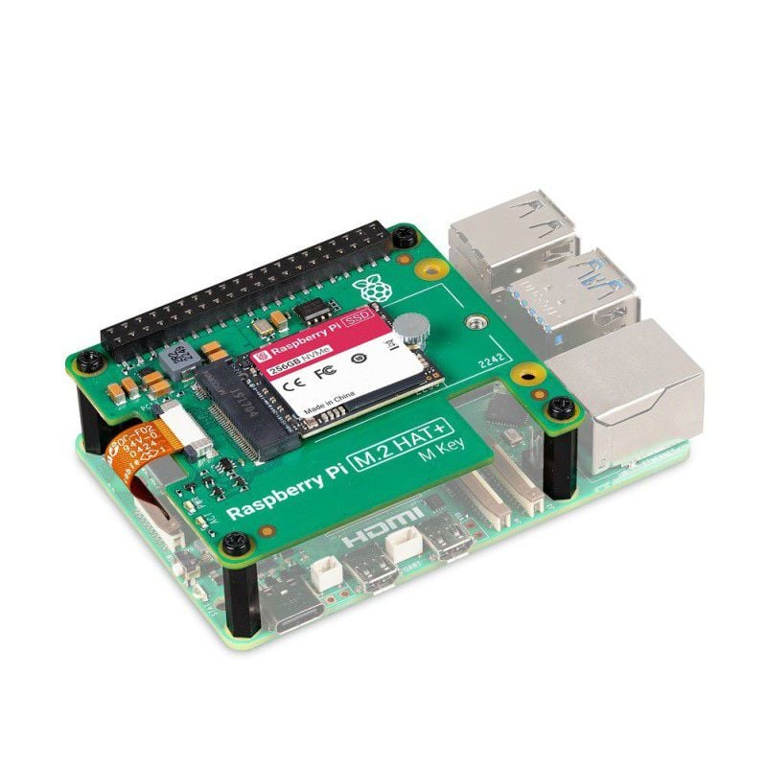

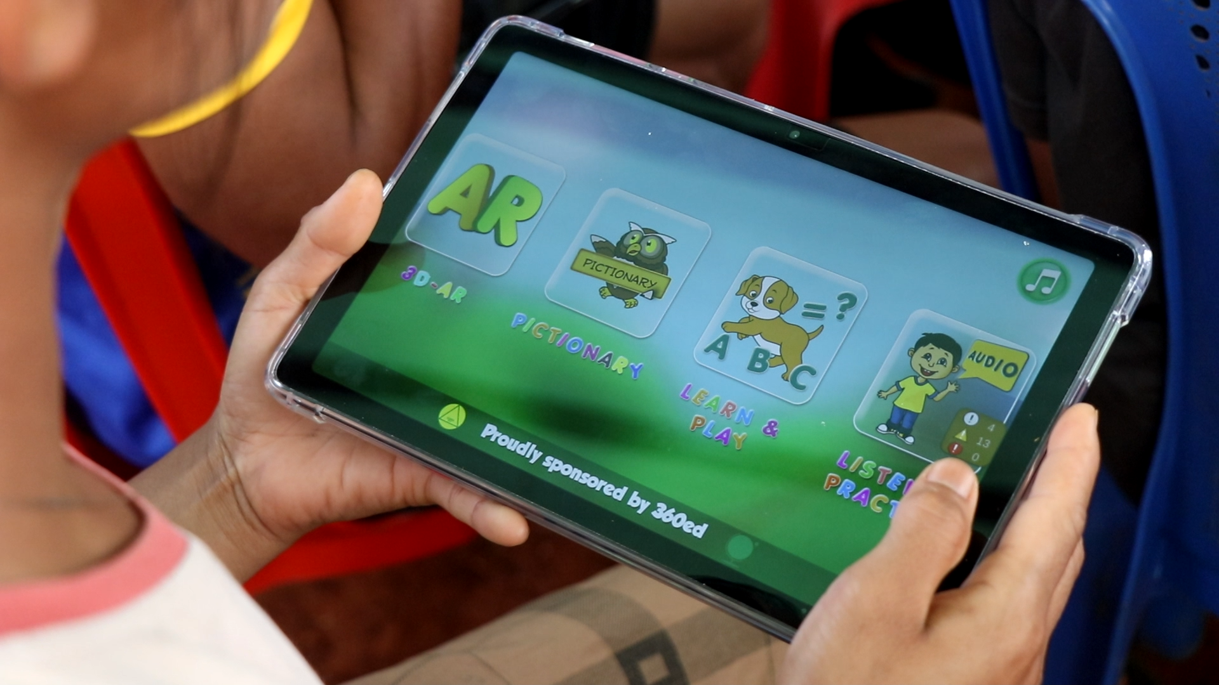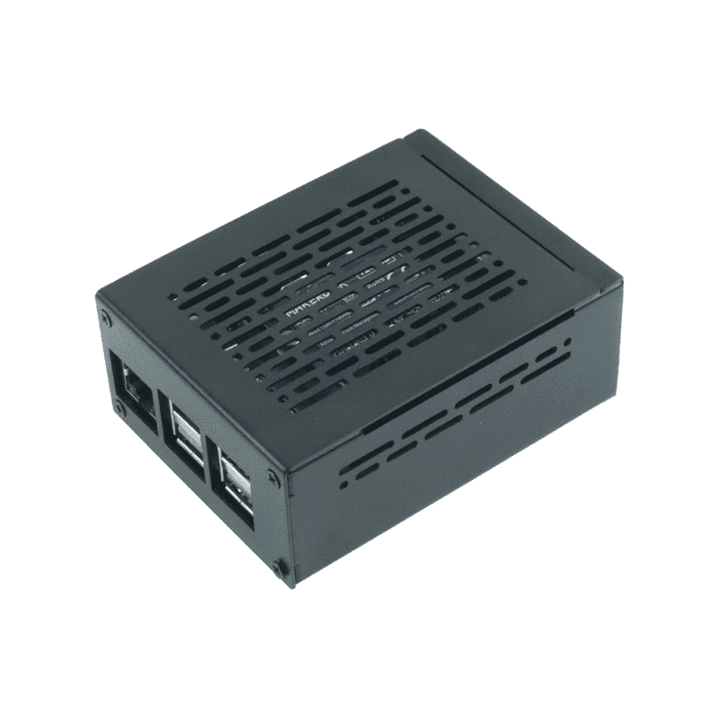

Raspberry PI Raspberry PI Tablets

Metal Case Board

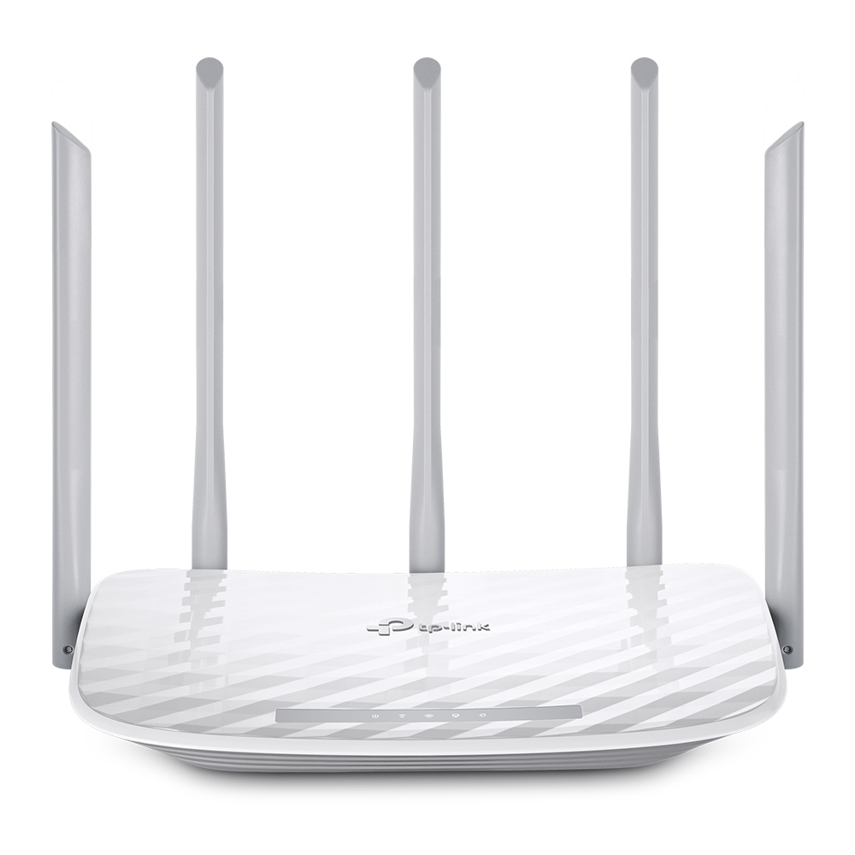

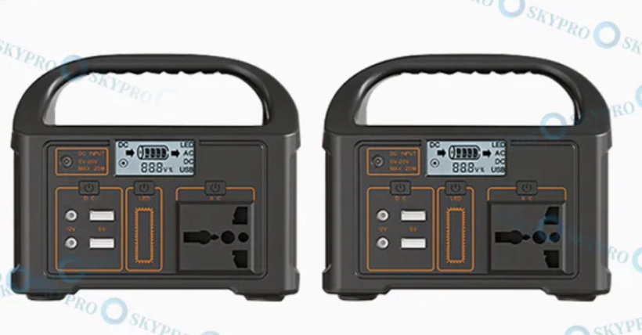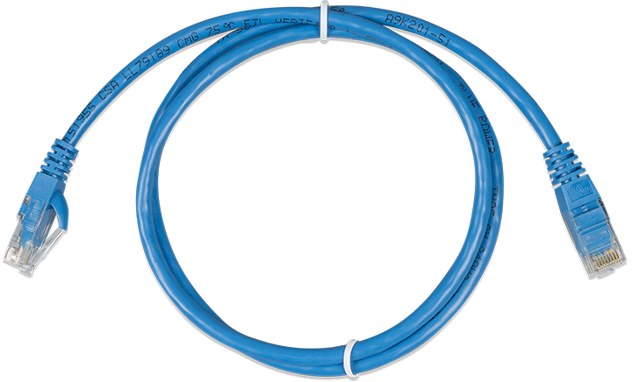

TP-Link Router Power Station Network Cables

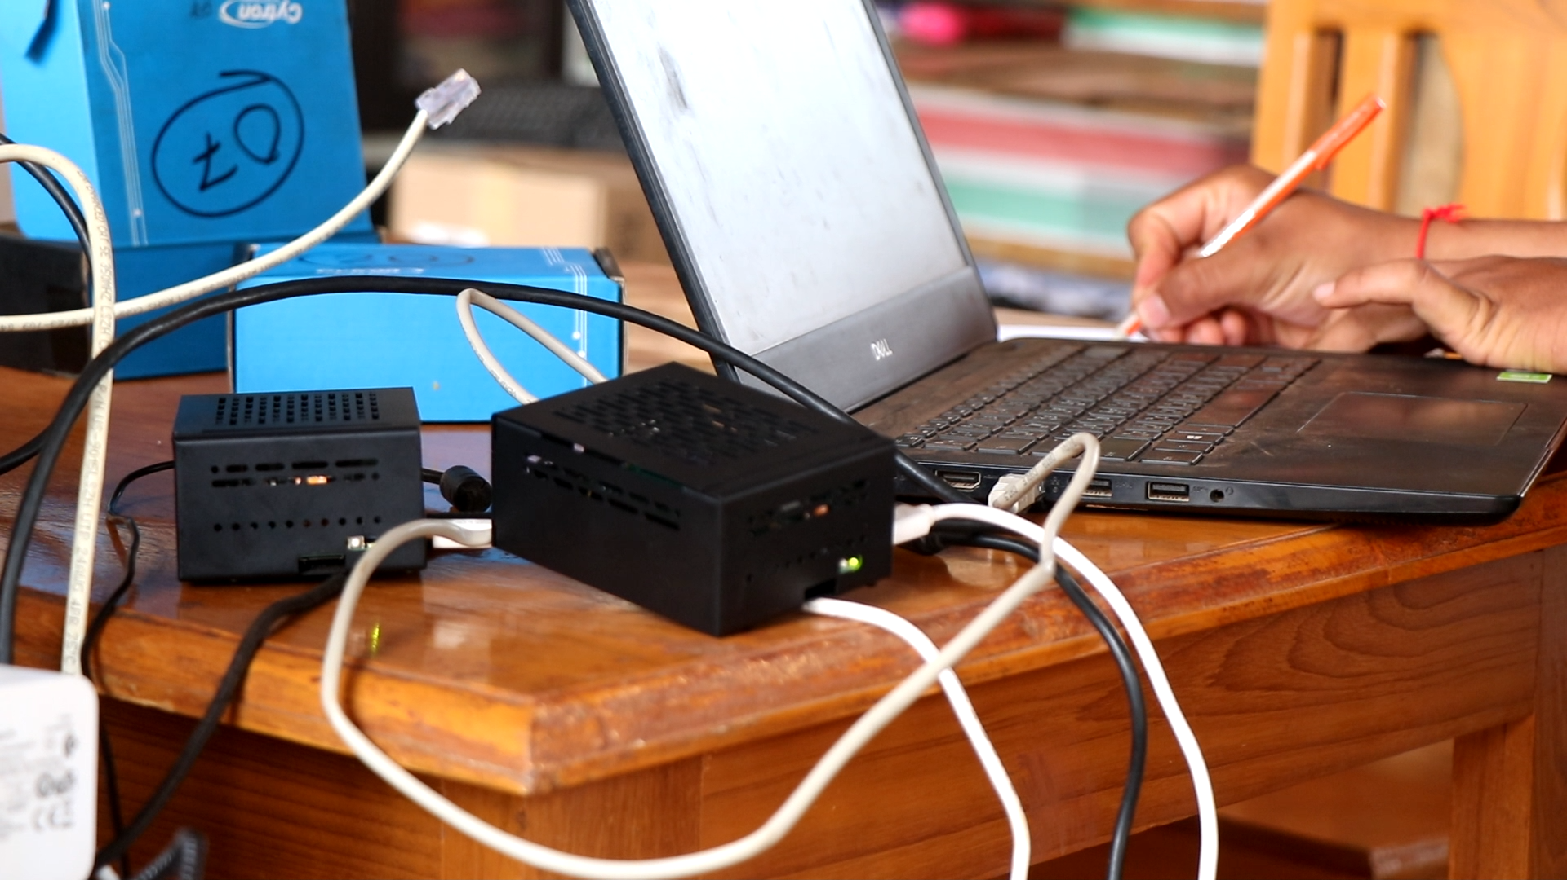

**FLB Platform - Setup**

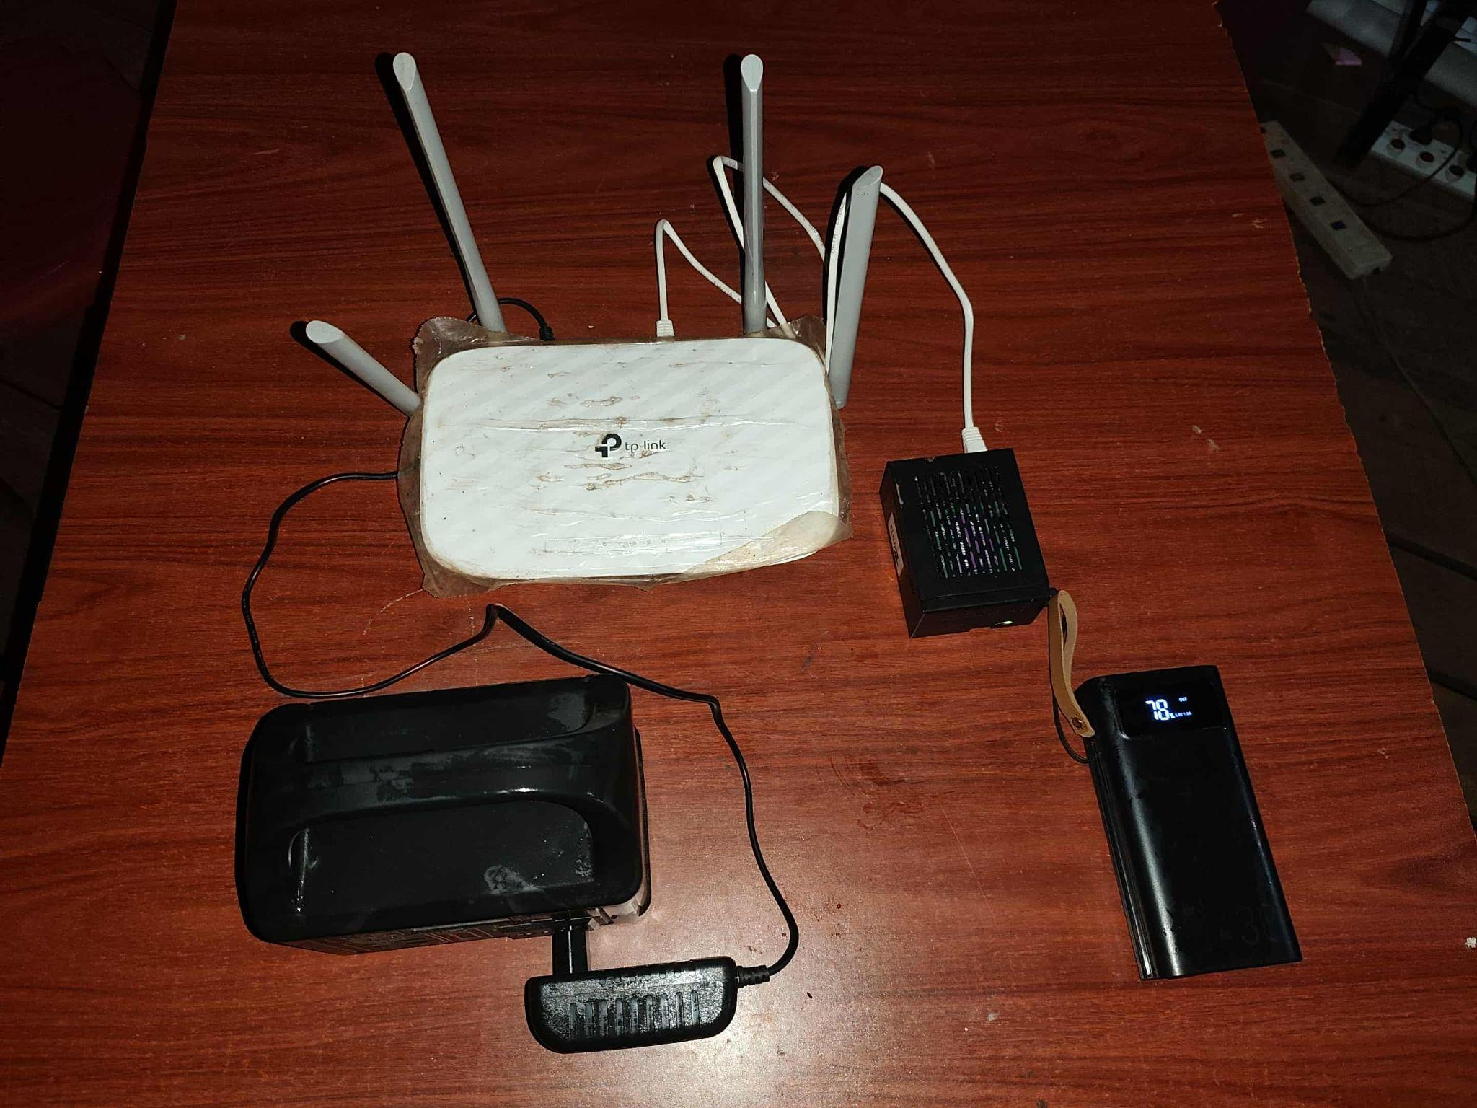

**FLB - Platform**

**Appendices - Software Components**

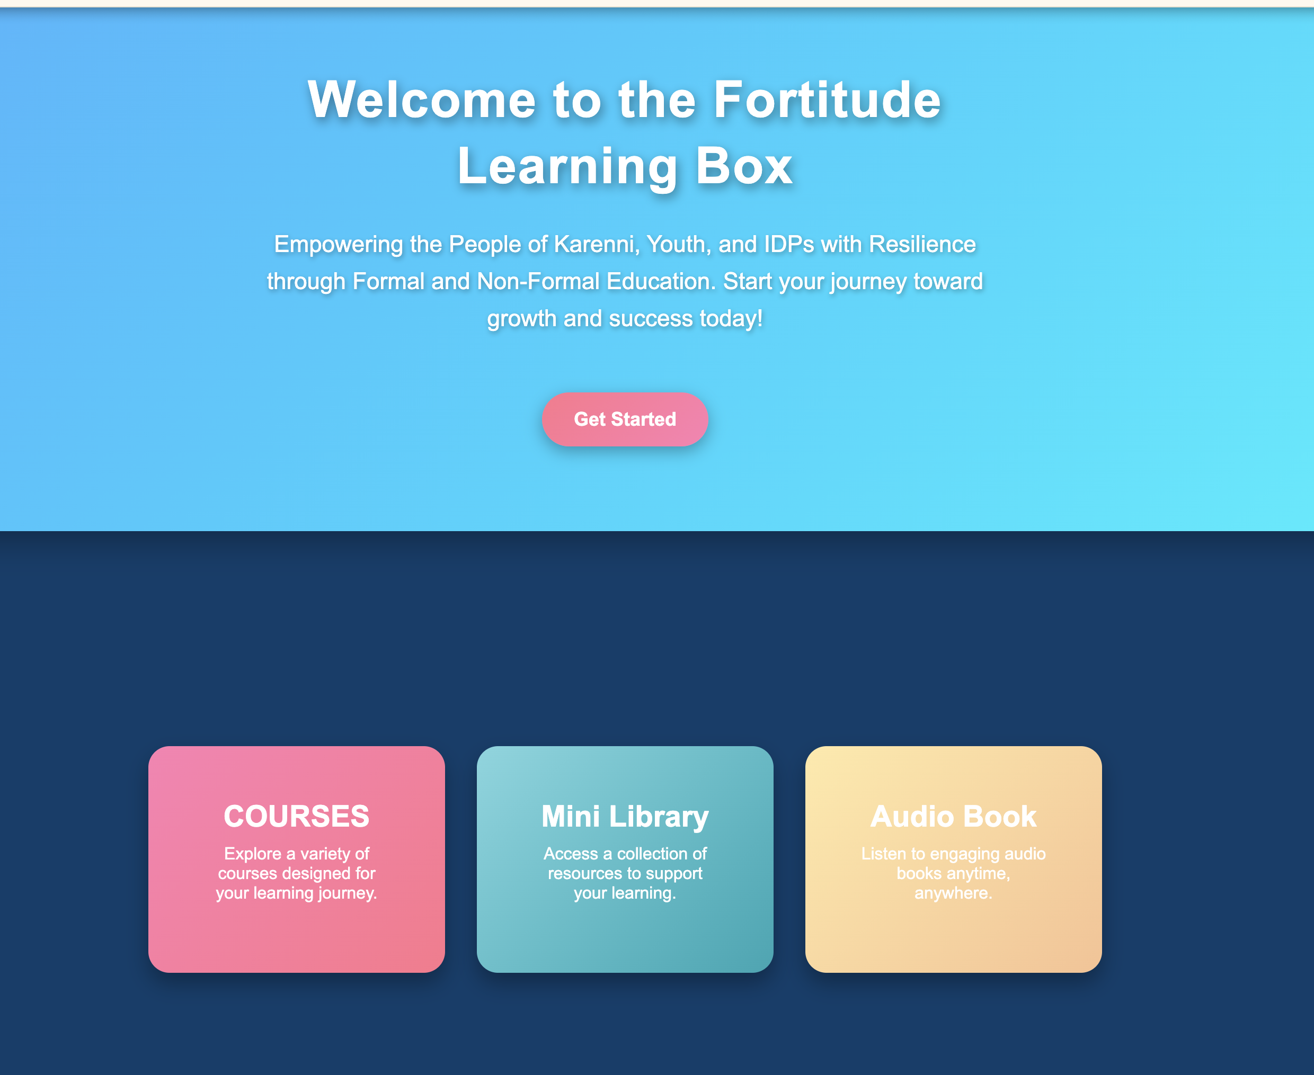



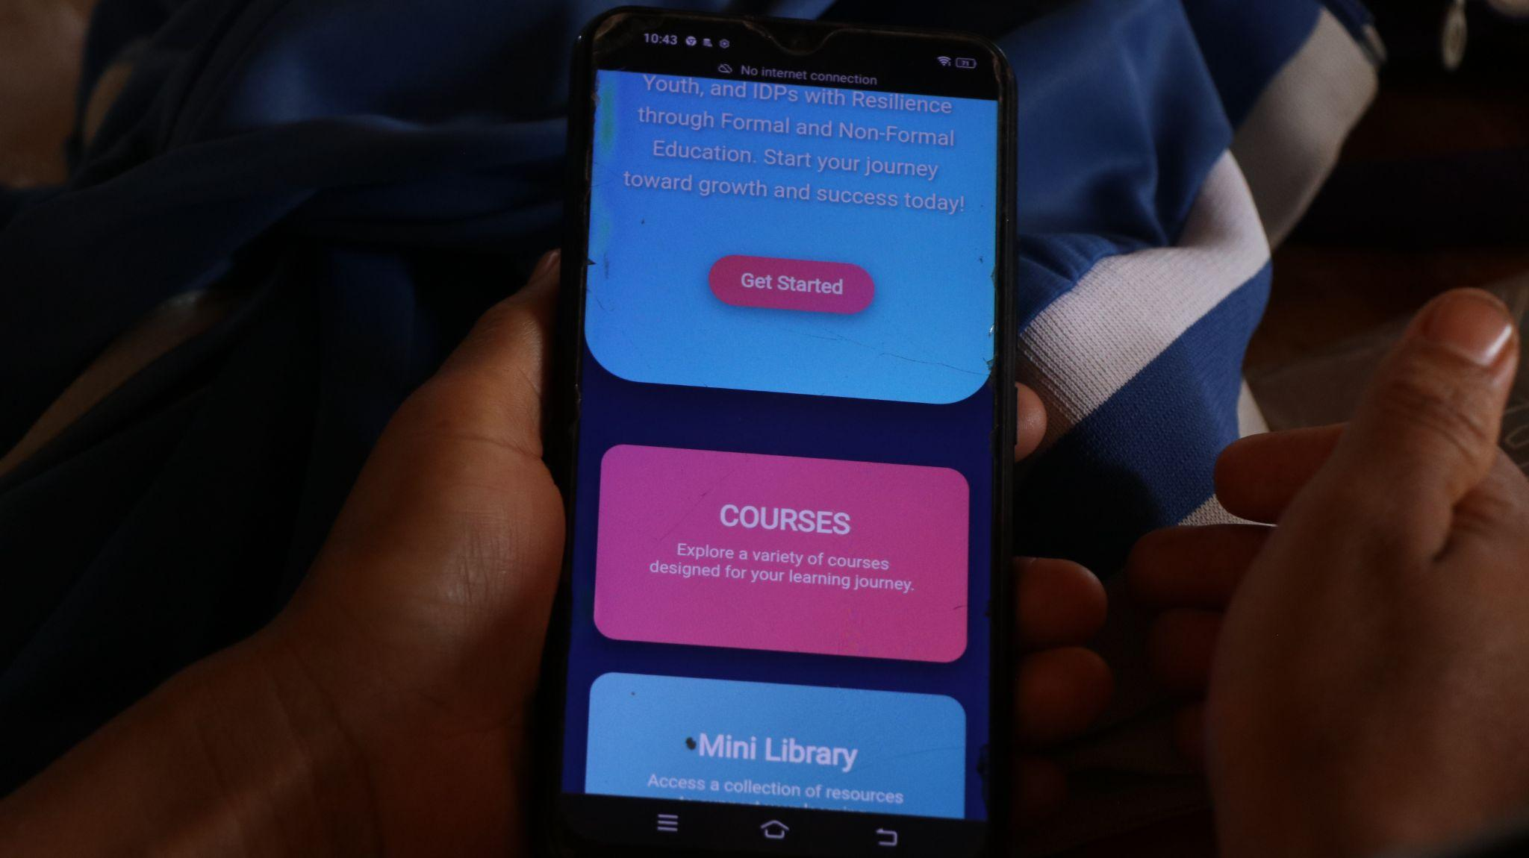

**Welcome Screen**

**Mobile View for Welcome Screen**

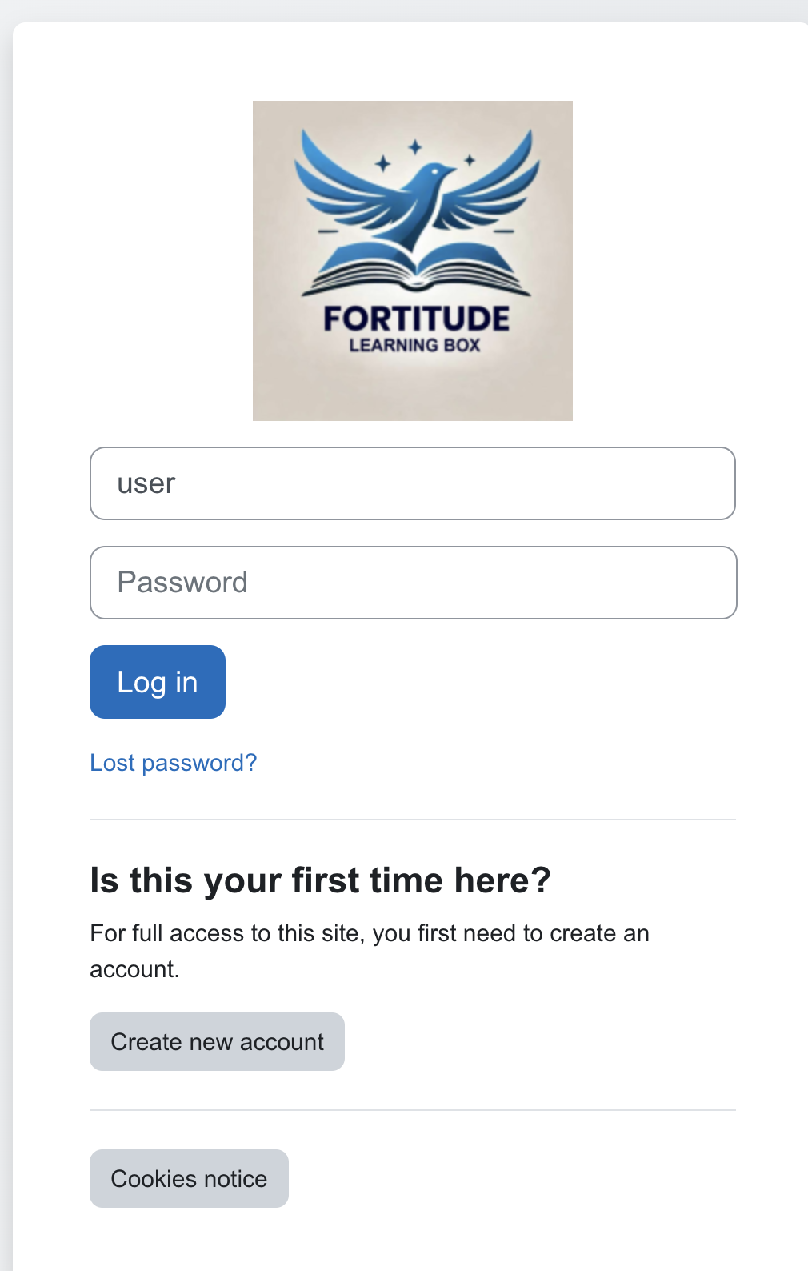

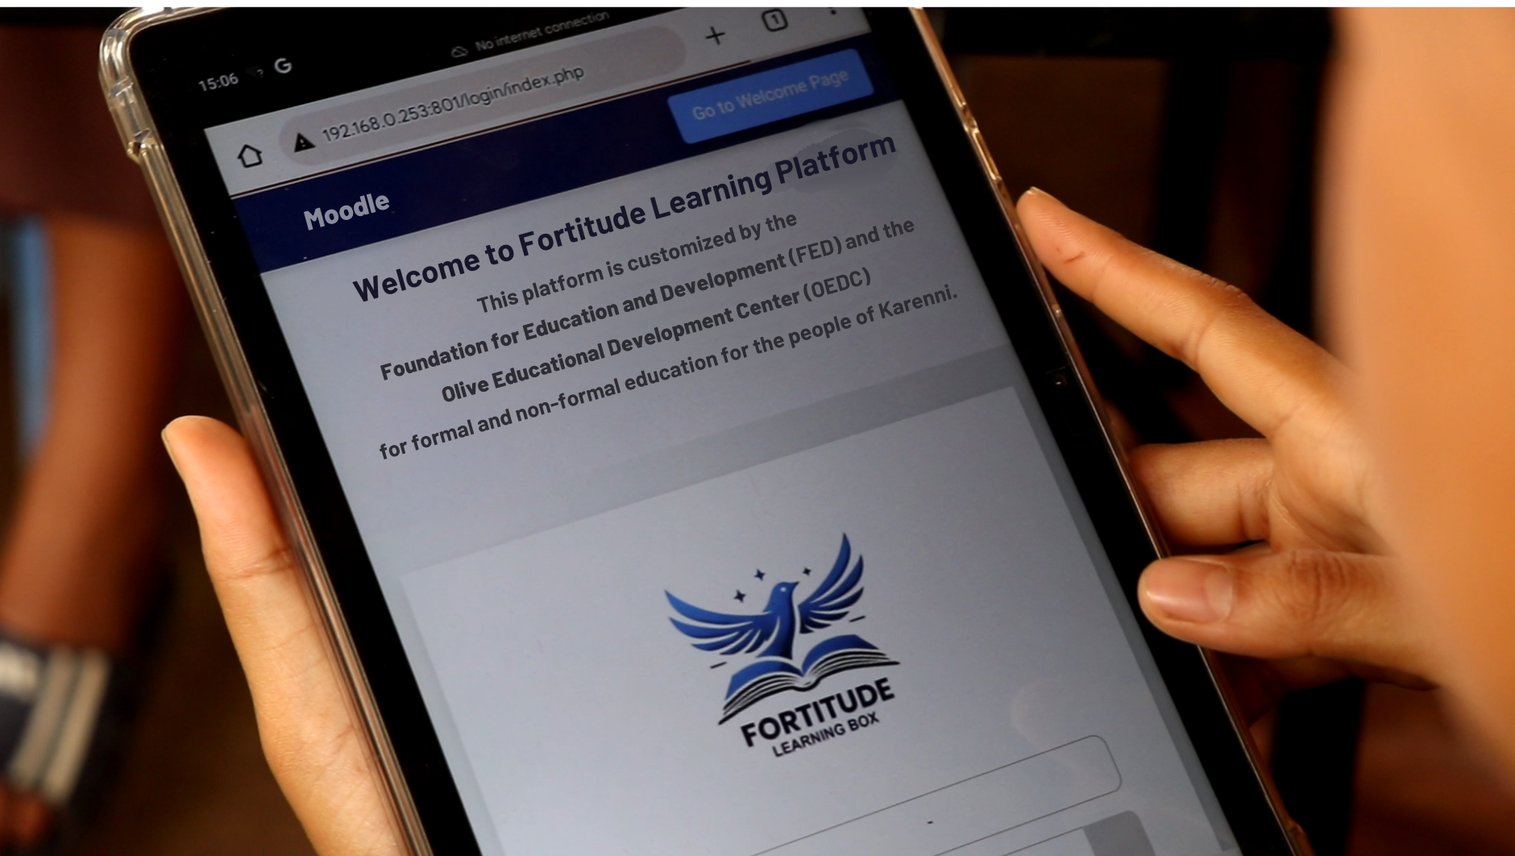

**Mobile View and Tablet View for FLB platform**